**FLEET UPDATES VERSION 5.0.2**

**Note: Sample lang ang mga data sa screenshots.**

1. Revised Motorpool Inspection Status Report.
2. 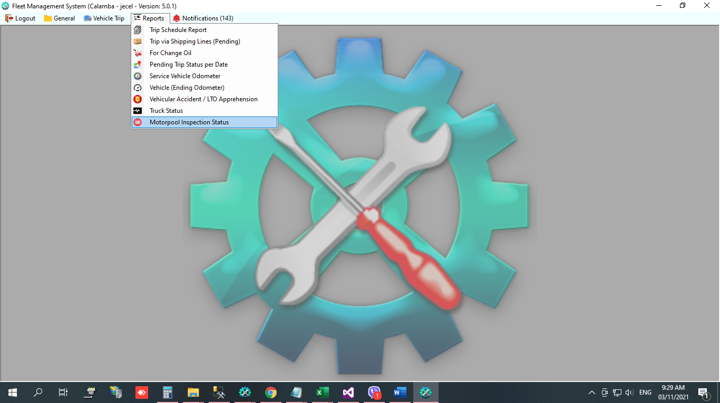In Reports menu, select Motorpool Inspection Status.
3. 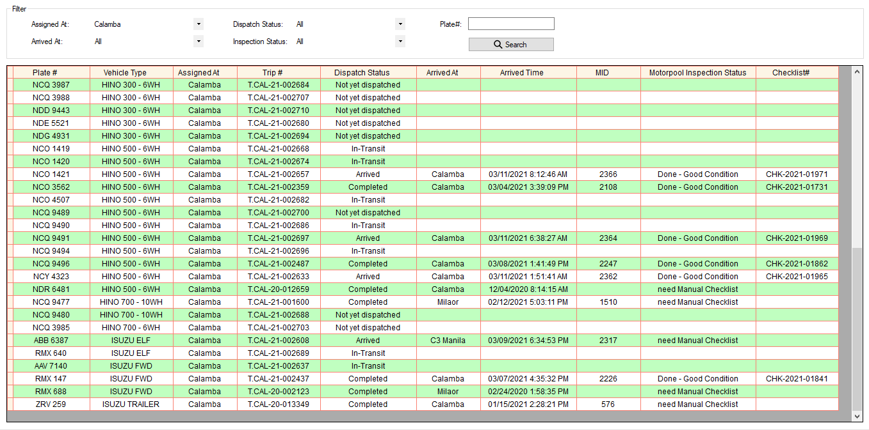Filter report.
4. Step 6 may filter na ng CUSTOMER TRUCK, JPSC TRUCK at TRUCKING TRUCK.
5. Select filter then click Refresh button.

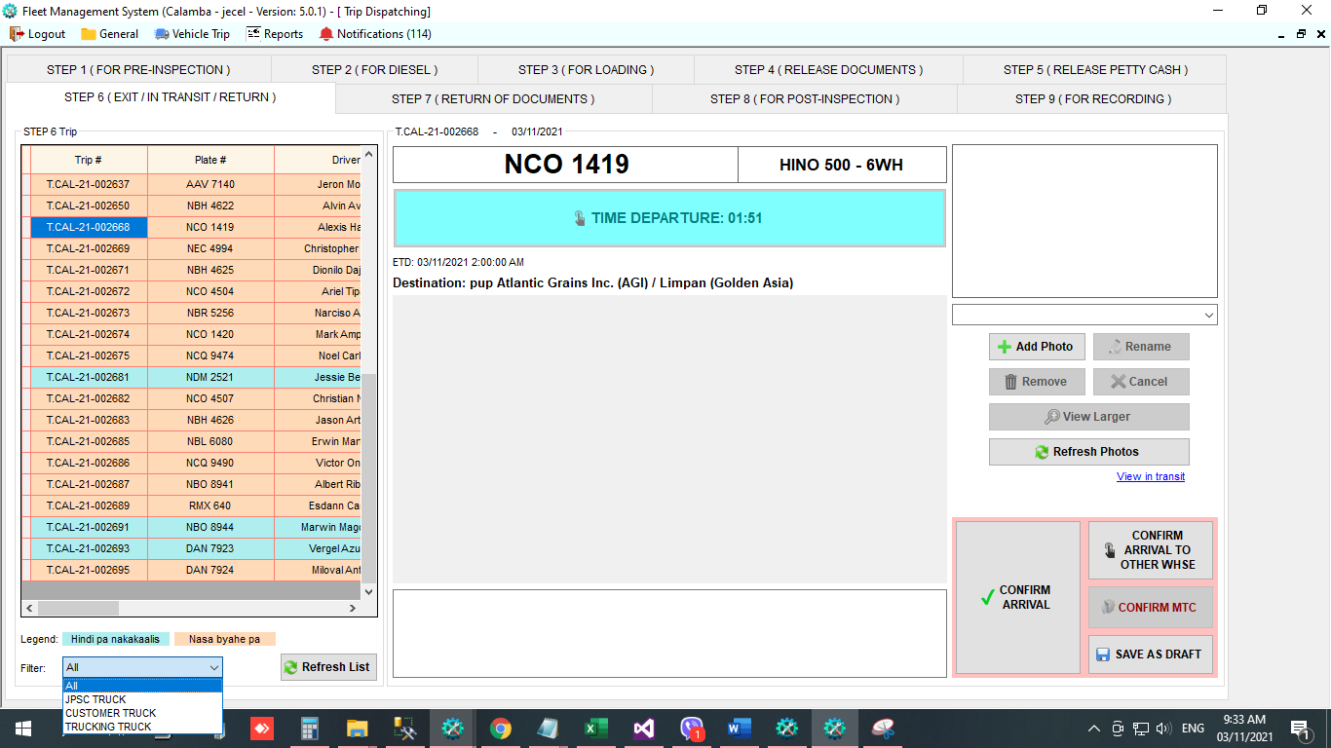

1. Calamba only. Kapag may transaction na kakargahan sa warehouse at sa agi sa iisang trip, may access na si Diesel Controller para mag attach ng Cleanliness Inspection Checklist.
2. Naayos na ang error na kapag may JPSC TAXI, at nag add to existing ng transaction di nakikita sa step7,
3. Truck Status

* Dito mag create ng truck status ang warehouse.
* One truck status per day only.

1. In Reports menu, select Truck Status.

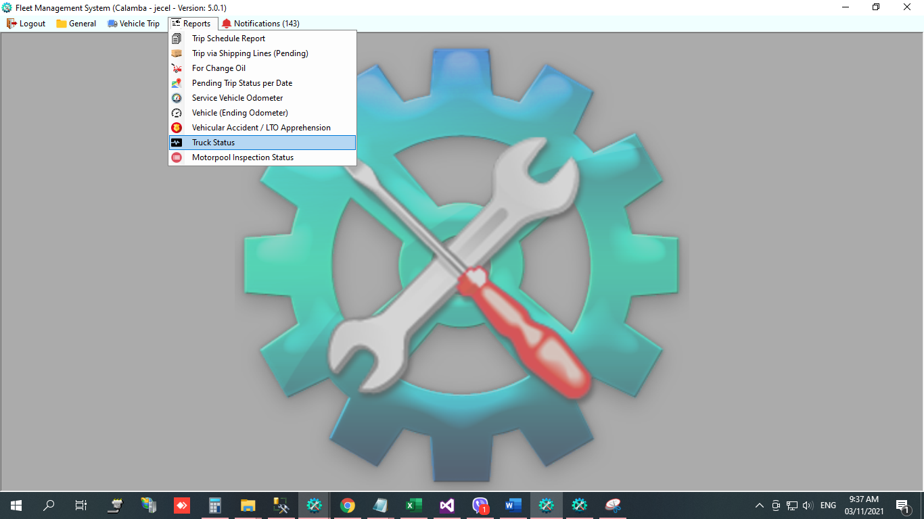

1. Click NEW.

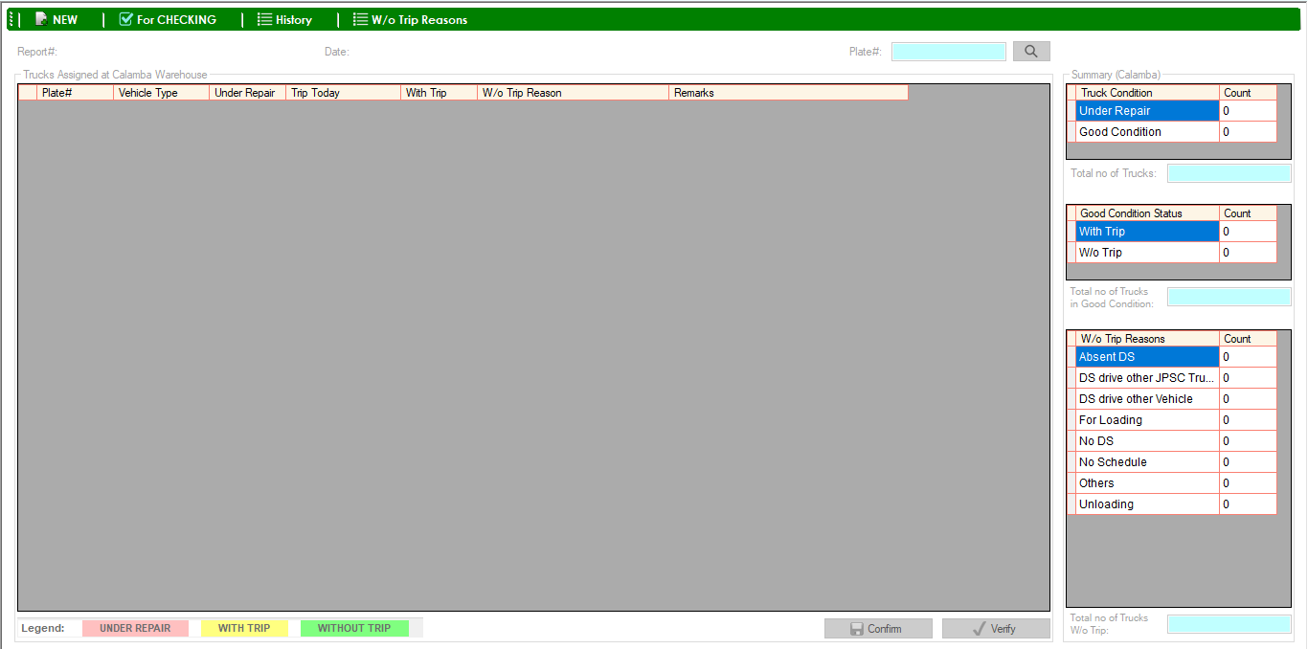

1. Mag show lahat ng plate# na naka assigned sa warehouse kung saan nag login. Kung may trip today ang truck, automatic naka check ang **With Trip** na column. Kung may connection ang fleet sa ibang warehouse, mache-check din doon kung may trip ang truck. Kung with trip, mag sho-show din ang trip# nito. Kung connected sa Motorpool, at ang condition ng truck ay under repair, automatic naka check ang **Under Repair** na column.

example: Nag login ako sa Calamba fleet kaya lahat ng plate# na makikita dito ay naka assigned sa Calamba Warehouse.

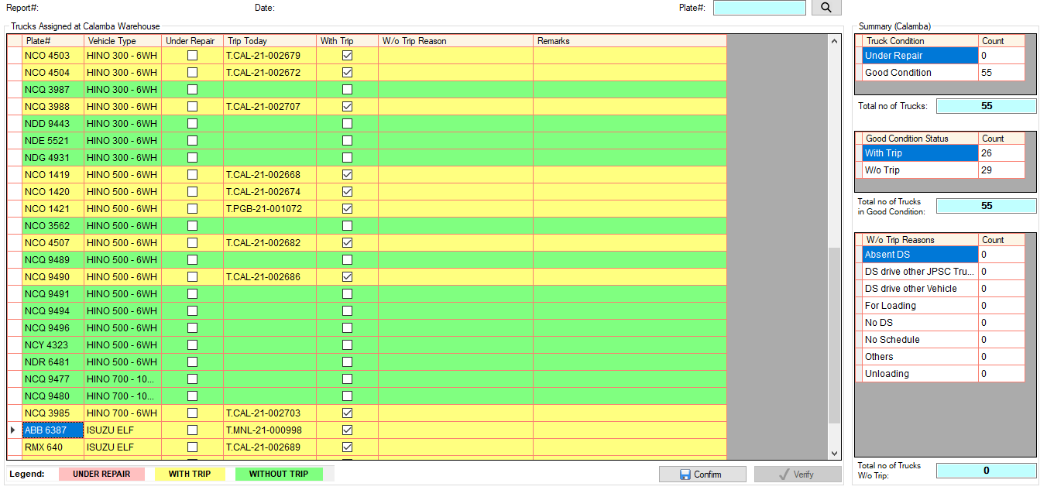

May trip today sa Calamba Fleet

May trip today sa Pagbilao Fleet

May trip today sa C3 Manila Fleet

Summary

1. 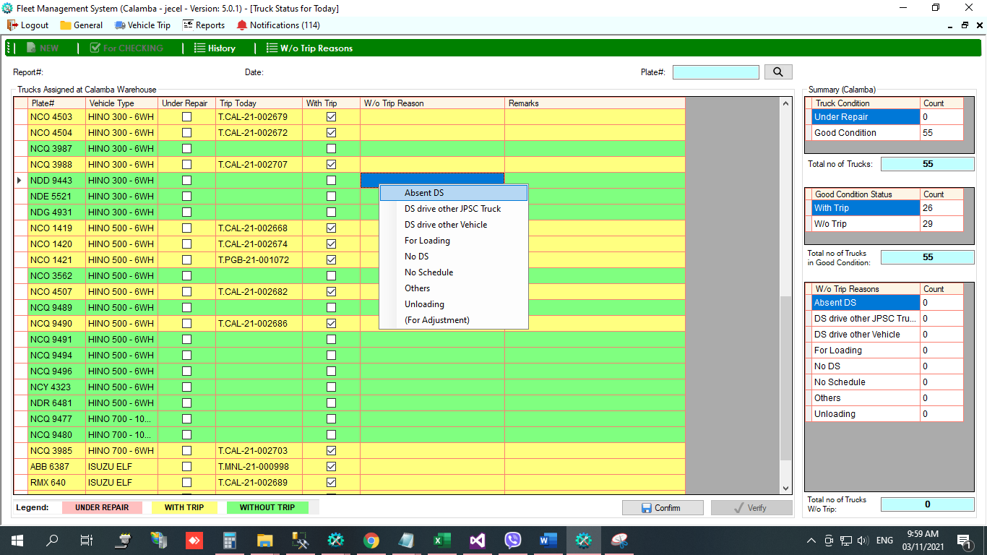Lahat ng mga plate# na naka highlight ng green ay without trip, meaning walang nakitang trip for today. Lahat ng without trip na truck kailangan lagyan ng reason kung bakit walang trip. Right click the plate#, then select reason.
2. Kada set ng reason, automatic ding nagbabago ang summary.

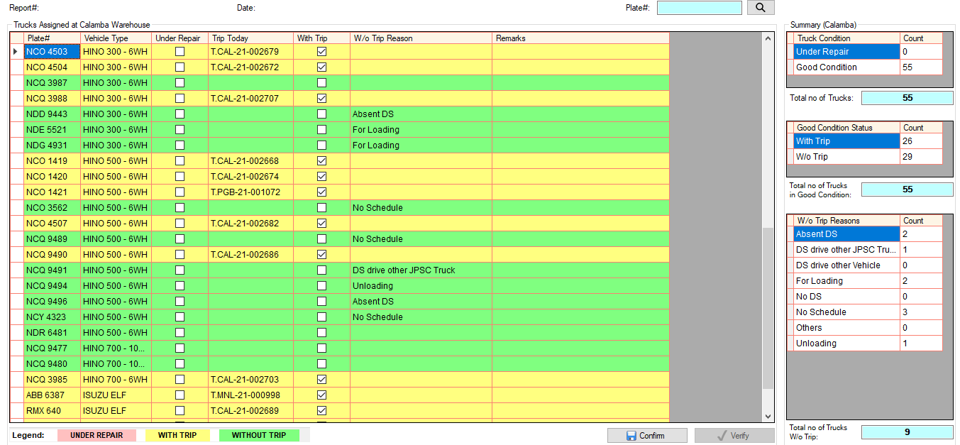

1. 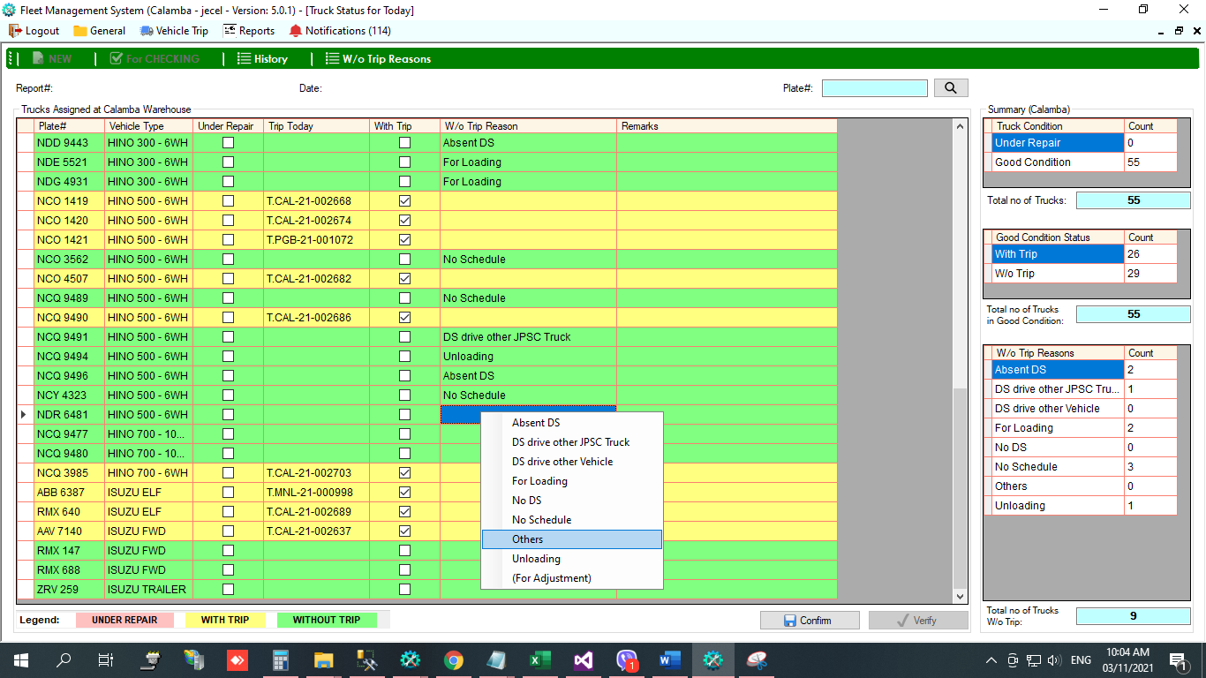Kung wala sa list ang reason, select **Others,** required na mag input ng remarks.

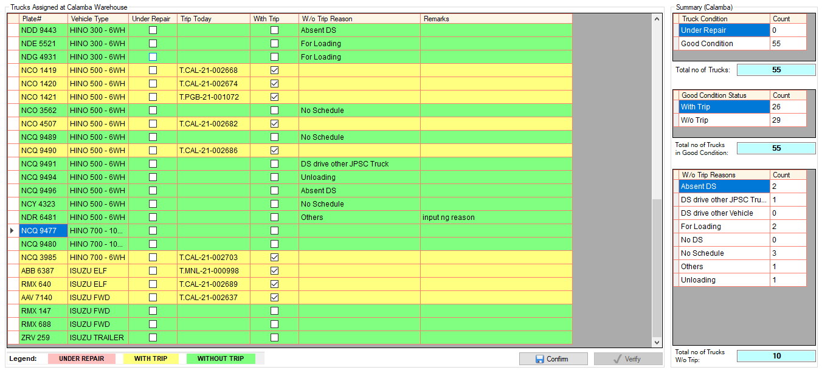

1. 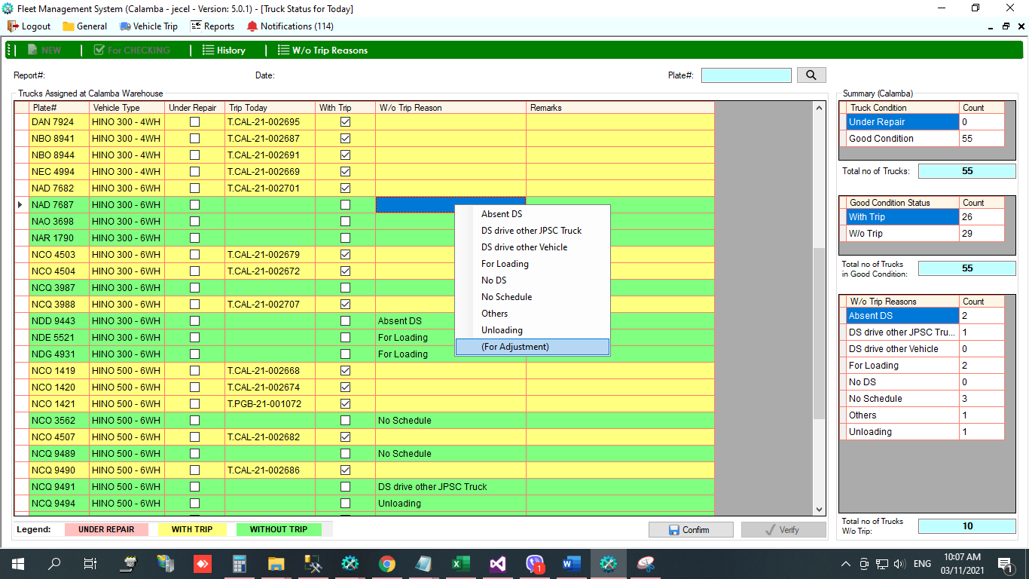Kung hindi nag automatic **With Trip** ang truck dahil hindi connected ang fleet sa ibang warehouse kung saan nandoon ginamit ang truck. Right click the plate#, then select **(For Adjustment)**, required ang remarks. Kapag for adjustment, logistics staff ang authorize na mag check ng **With Trip** na column, provided na nacheck talaga na may trip ang truck sa ibang warehouse. (same kapag hindi automatic Under Repair dahil hindi connected sa Motorpool)

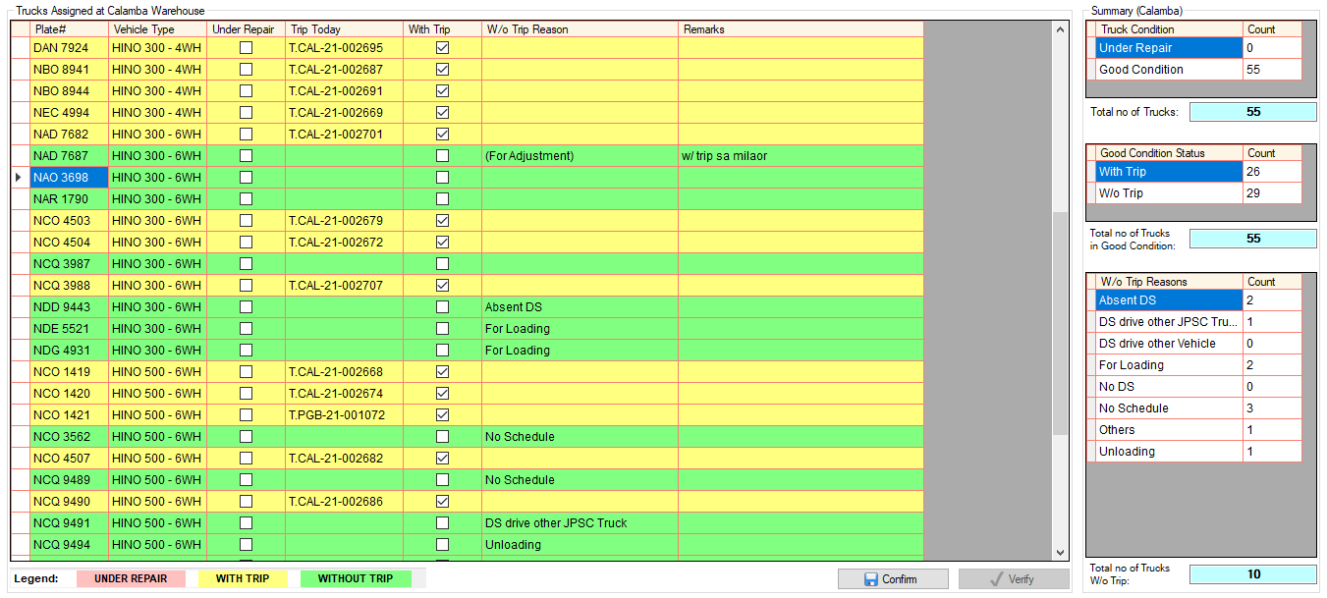

1. 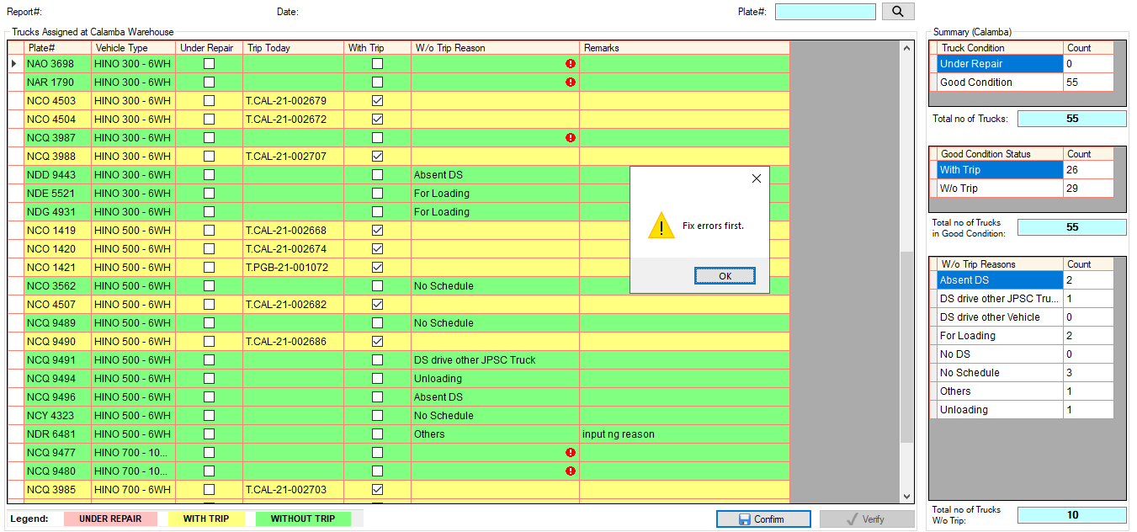Cannot confirm if may plate# na walang reason.
2. Kung complete na, click Confirm button. Then input password, then click OK button.

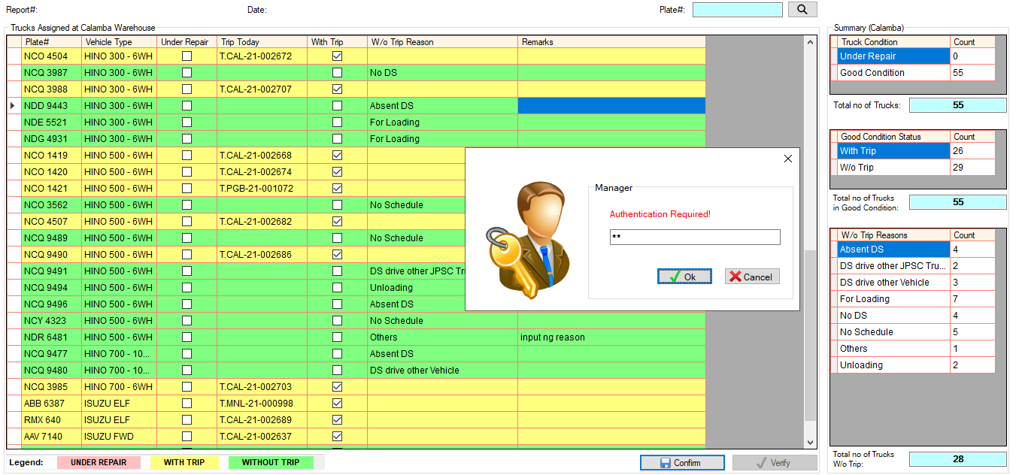

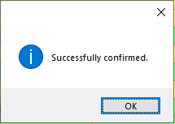

1. Once confirmed, kailangan i-verify ni logistics staff. Open Truck Status module, then click **For Checking.**

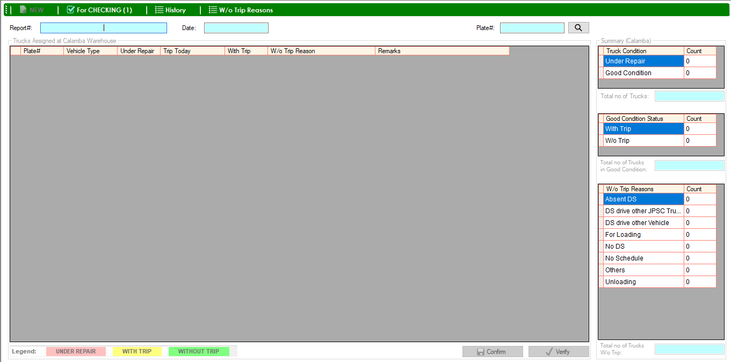

1. 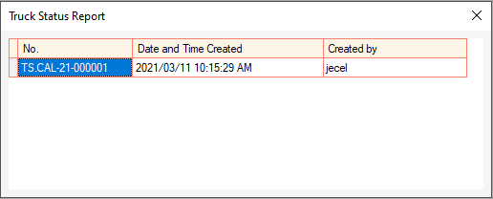Double click the report#.
2. 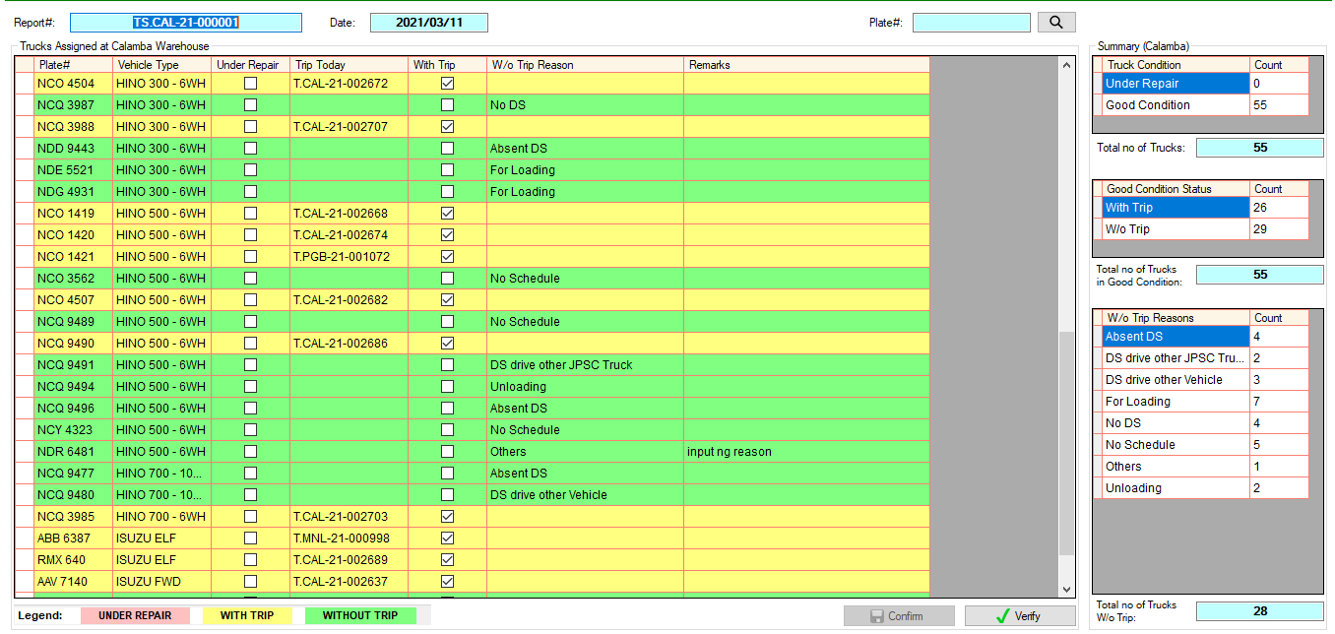Confirmed report will show.
3. 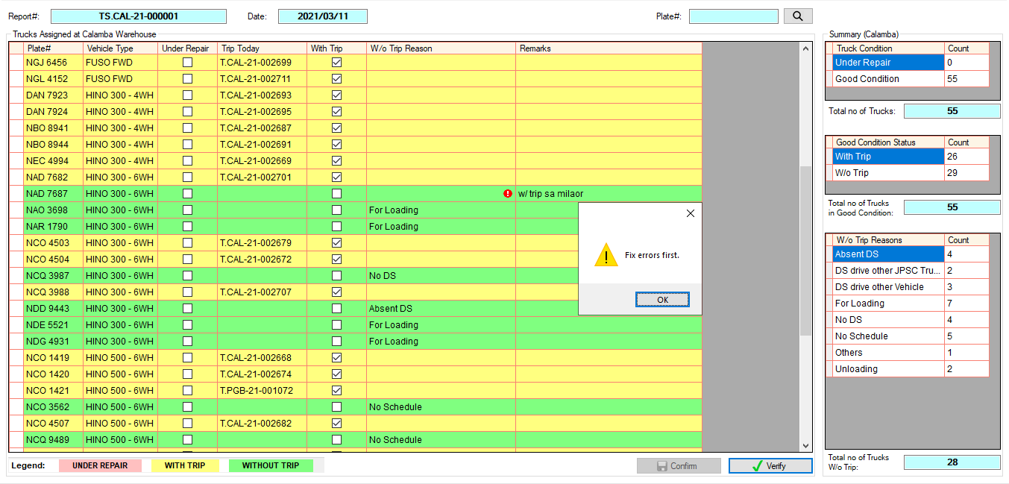Check the details, then click Verify button.
4. 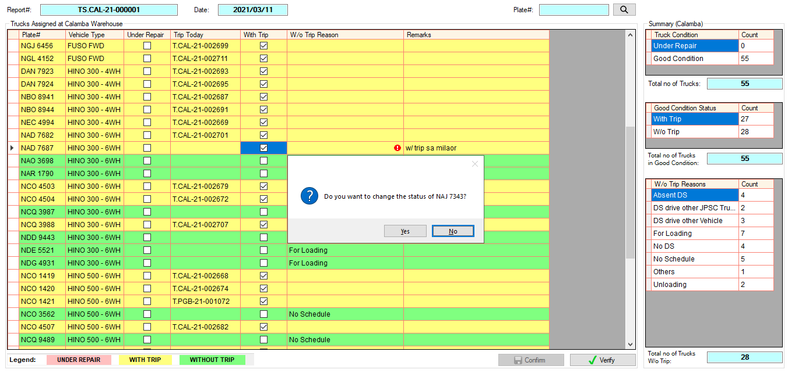Kung may plate# na walang reason, ito yung mga **(For Adjustment)** ni warehouse. Based sa example, ang remarks ay with trip sa milaor, kung nagbyahe talaga sa milaor ang truck, check the corresponding **With Trip** checkbox column.

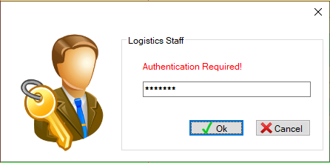

1. 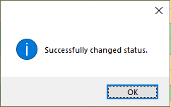Click Yes to continue. Then input password, then click Ok button.
2. 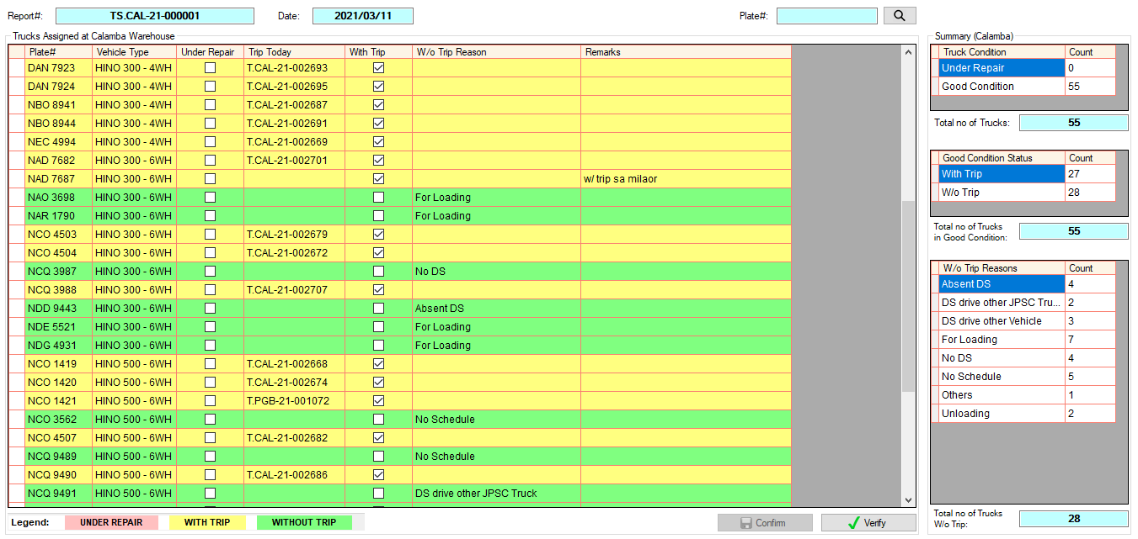Kung nacheck na at kumpleto na, click Verify button.
3. 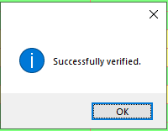Input password, then click Ok button.
4. To check previous reports, click **History**.

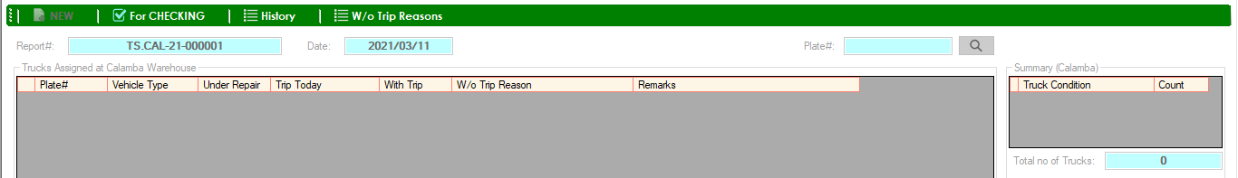

1. 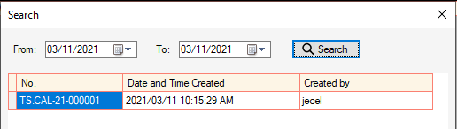Search report date, then double click the report#.
2. Verified Report will show. Summary is highlighted if the report is already verified.

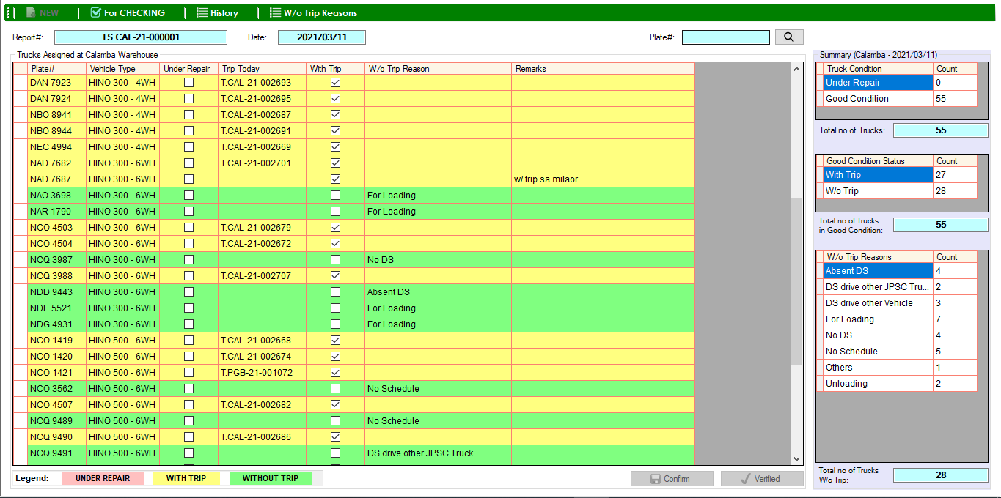

1. Click **W/o Trip Reasons** to show the list of reasons.



1. POI
2. 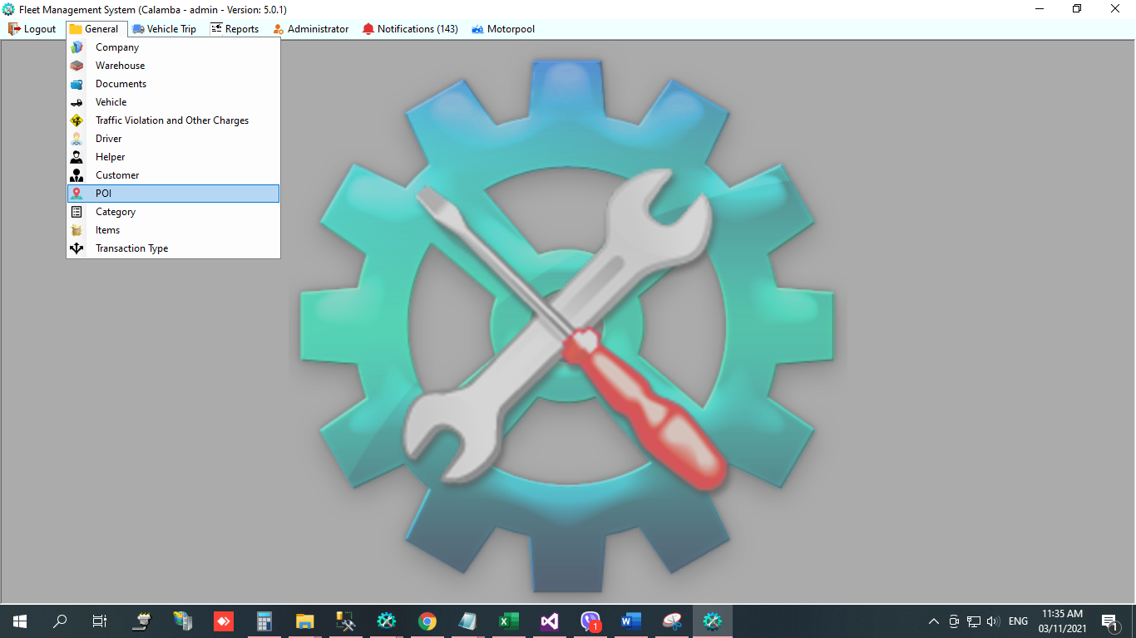In General menu, select POI.
3. 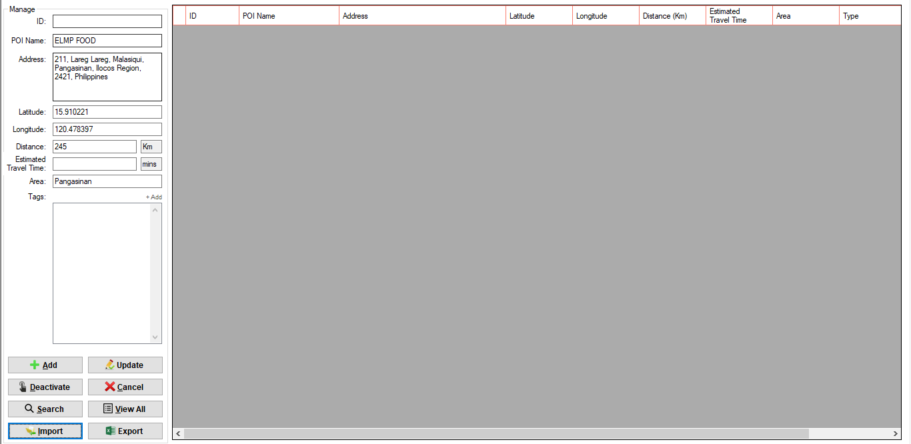Input details, then click Add button. (for Administrator and Logistics Staff only)
4. 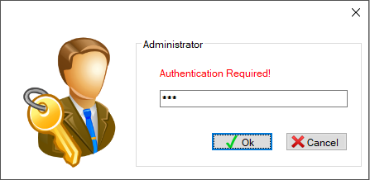Input password, then click Ok button.

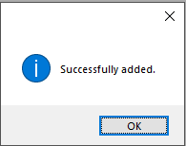



1. Add POI Tags (for Administrator and Logistics Staff only)
2. Select POI, then click Update button.

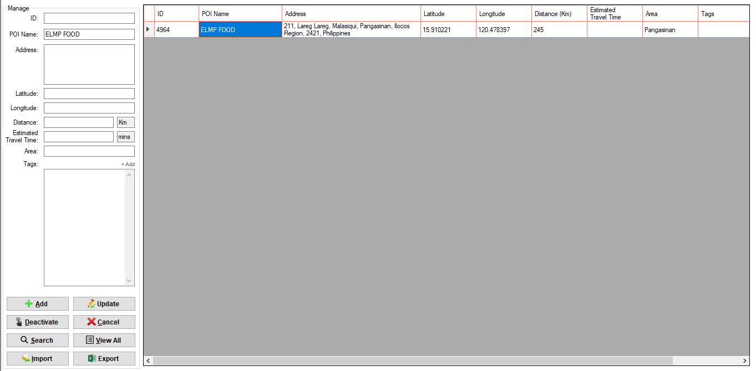

1. Click Add link beside the Tags label.

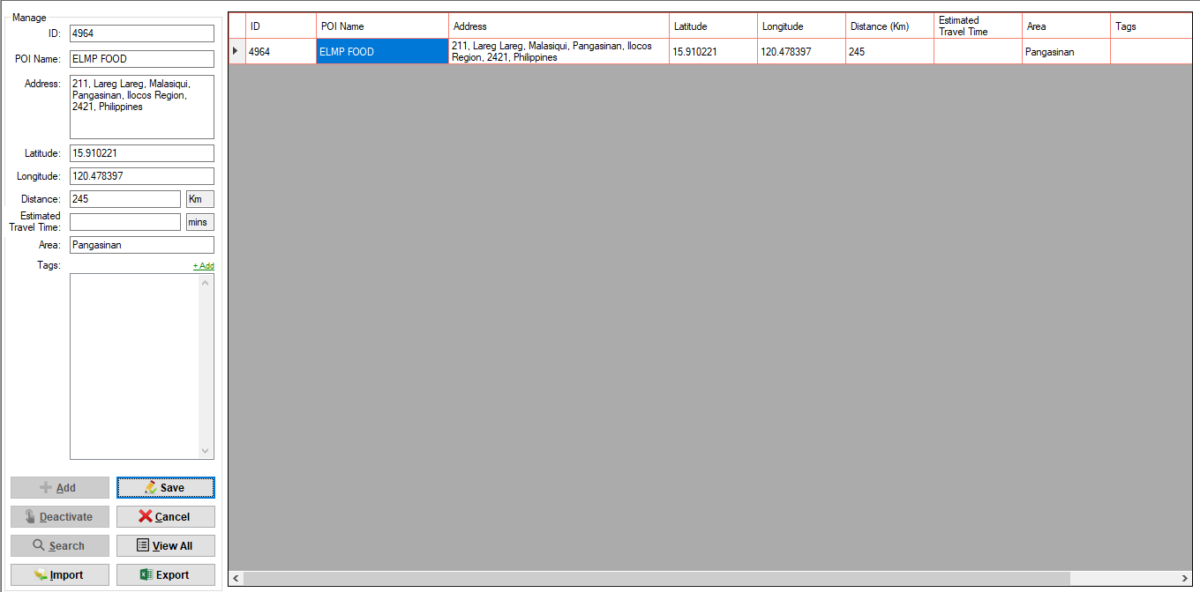

1. 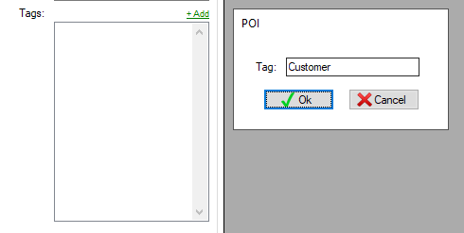Input tag, then click OK button.
2. Click Save button.

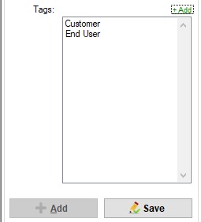

1. 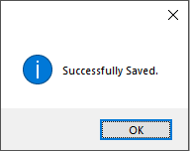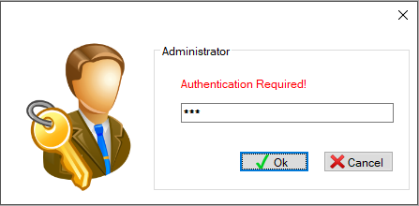Input password, then click Ok button.

